ILLINOIS POLLUTION CONTROL BOARD
July 26, 2018
IN THE MATTER OF:  SDWA UPDATE, USEPA REGULATIONS (January 1, 2018 through June 30, 2018) | )  )  )  )  ) | R19-8  (Identical-in-Substance Rulemaking - Public Water Supplies)
Proposed rule. Dismissal order.
ORDER OF THE BOARD (by C.M. Santos):
Section 17.5 of the Environmental Protection Act (Act) (415 ILCS 5/17.5 (2016)) requires the Board to adopt regulations that are “identical in substance,” as defined at Section 7.2 of the Act, to the National Primary Drinking Water regulations (NPDWRs) adopted by the United States Environmental Protection Agency (USEPA). These regulations implement sections 1412(b), 1414(c), 1417(a), and 1445(a) of the Safe Drinking Water Act (SDWA), 42 U.S.C. §§ 300g-1(b), 300g-3(c), 300g-6(a) & 300j-4(a) (2015). USEPA has codified its SDWA regulations at 40 C.F.R. 141 through 143.
The Board reserved this docket for any SDWA amendments adopted by USEPA between January 1, 2018 through June 30, 2018. During that period, USEPA did not act in any way regarding the NPDWRs that would require Board action. Therefore, no action is necessary, and the Board dismisses this docket.
IT IS SO ORDERED.
I, Don A. Brown, Clerk of the Illinois Pollution Control Board, certify that the Board adopted the above order on July 26, 2018, by a vote of 5-0.
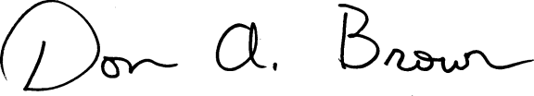
Don A. Brown, Clerk
Illinois Pollution Control Board

